India Replica Server Clean Up Rule
Schindler CRD Applications

Exported on 2025-08-19 06:10:11

Table of Contents

1 Prerequisite: 3
2 Procedure: 4
3 Clean Unreferenced Files: 8

Prerequisite:
- Need admin access on Windchill.

Procedure:
- Please verify the vaults size on Replica server.
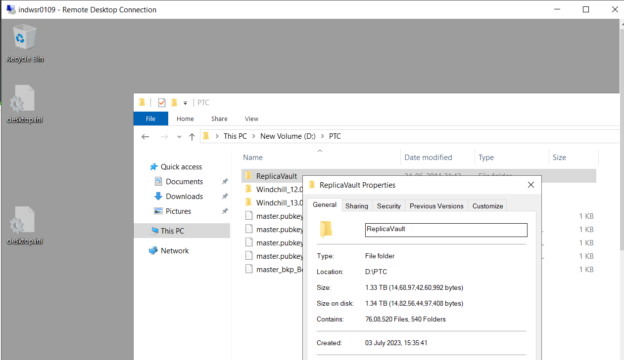

2. Please verify the vaults size on Master server.
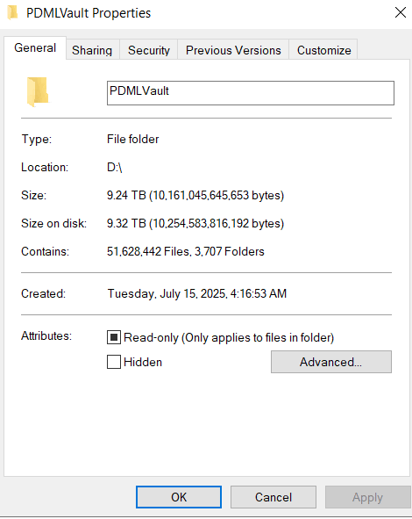

3. Make sure the below property is available under master server properties.
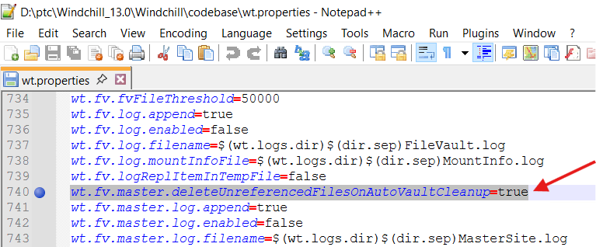

4. Log into Windchill as admin.
5. Navigate to site → Utilities → File Server Administration.
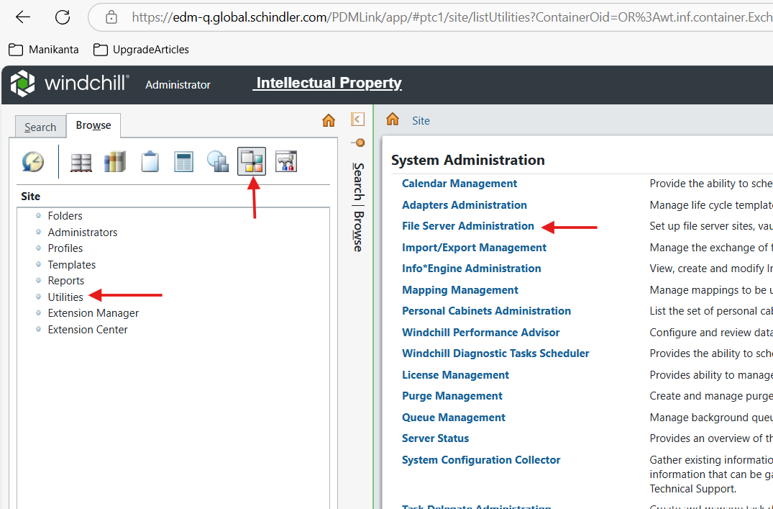

6. Click on Vault Configuration.
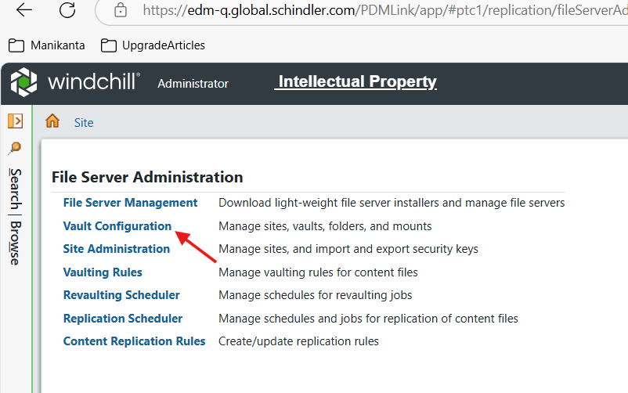

7. Select Replica_IND → click on Object → click on Define Content Cleanup Rules.
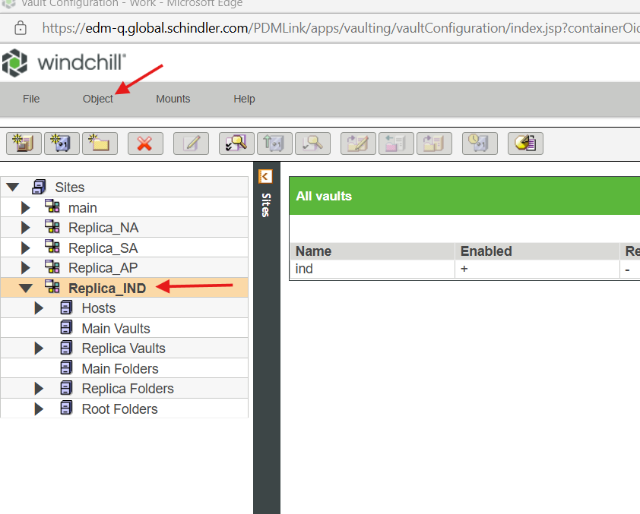

8. Provide the details as shown below and click on Run Cleanup Now.
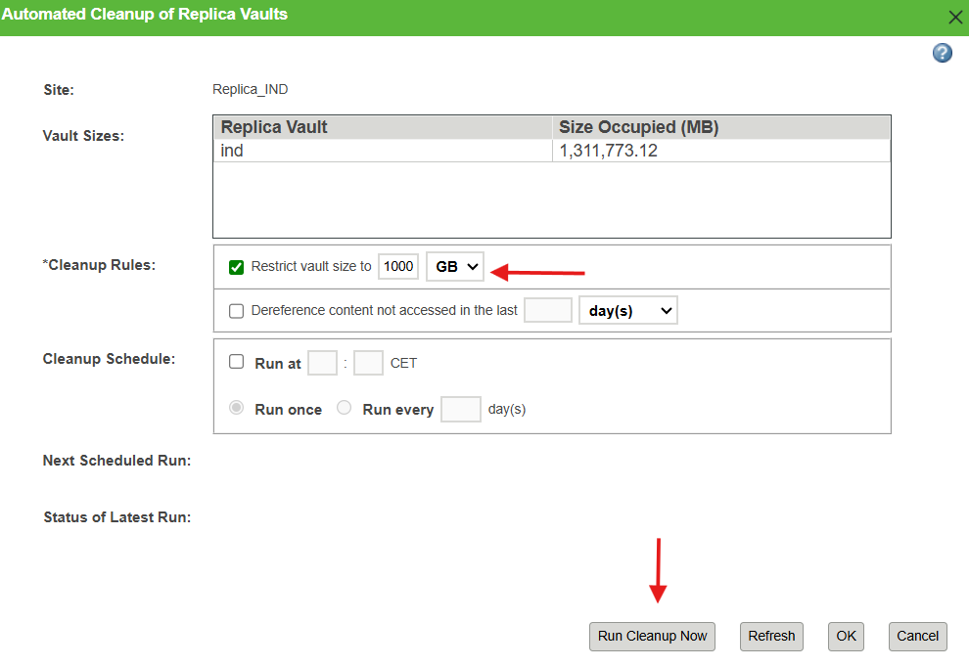

9. Click on Ok.
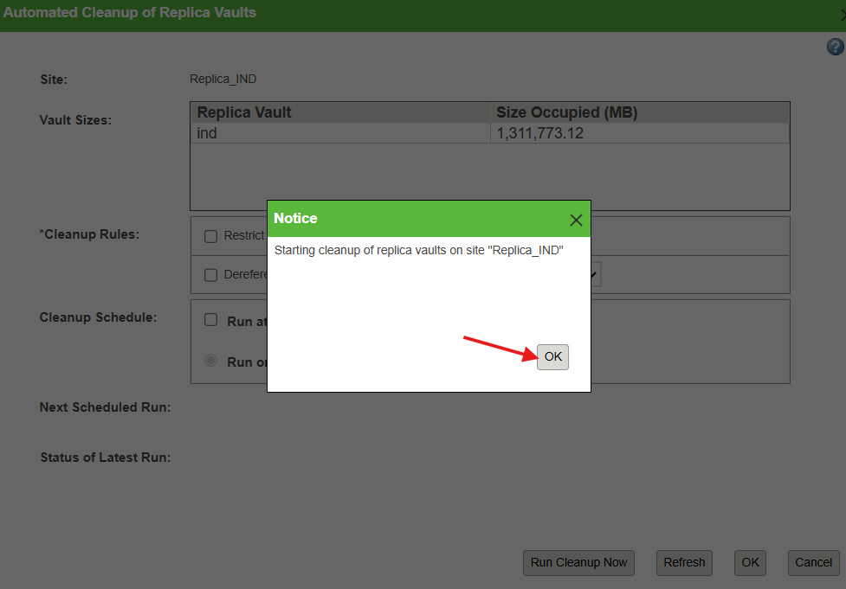

10. Content cleanup rules started executing.
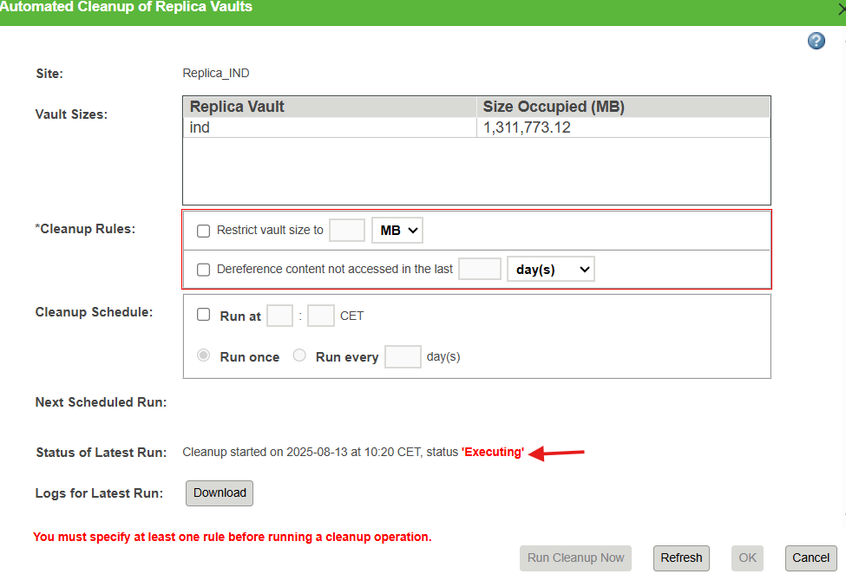

11. Execution will take some time (it took 1hr).
12. Verify for the log files to see the execution results.

Clean Unreferenced Files:
- Verified the vault size after content cleanup execution and observed that the size is 1.11TB.
- As per the content cleanup rule the size should reduce to 1.0 TB.
- Assuming that there are some unreferenced files which are dereferenced as a part of Remove Unreferenced File action on this File Server.
- Planned to clean unreferenced files.
- Log into Windchill as admin.
- Navigate to site → Utilities → File Server Administration.
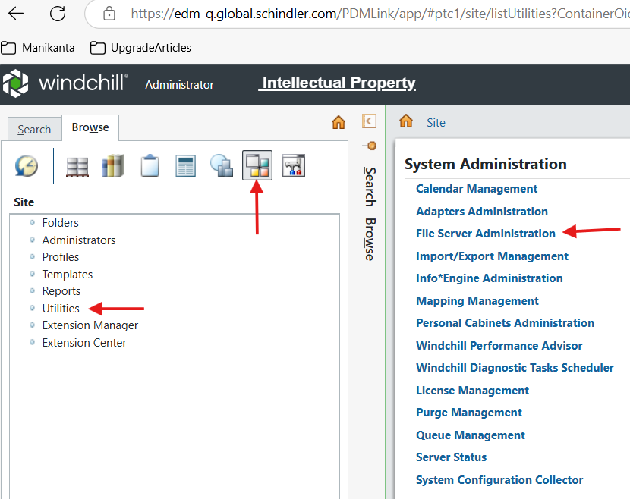

7. Click on Vault Configuration.
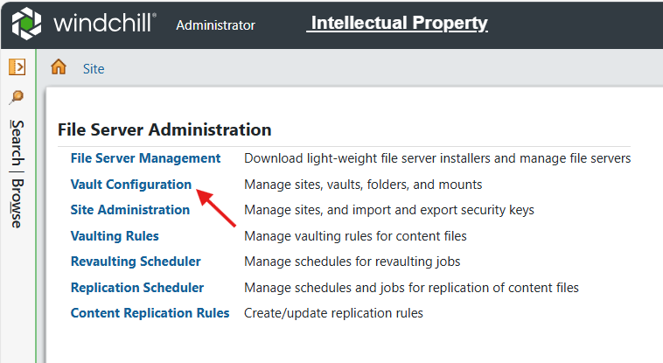

8. Expand Replica Vaults → select the Replica → click on Object → click on Remove Unreferenced File.
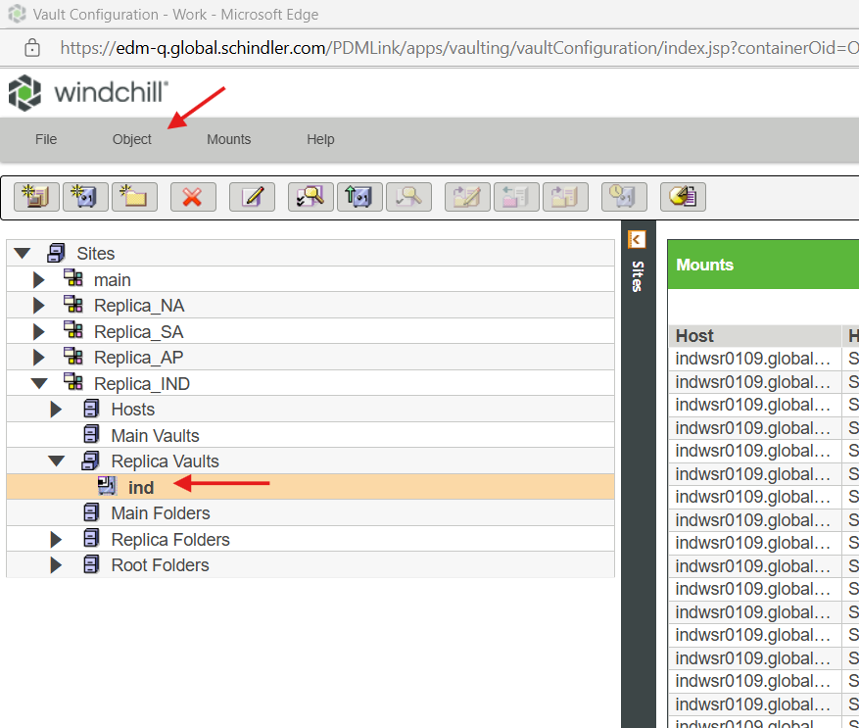

9. Click on Ok.
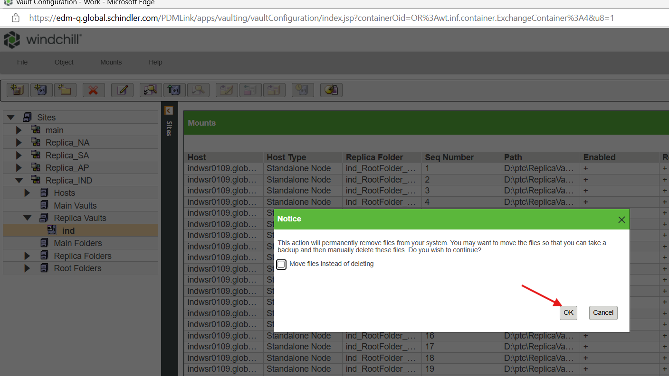

10. Job is initiated in the background to clear the files.
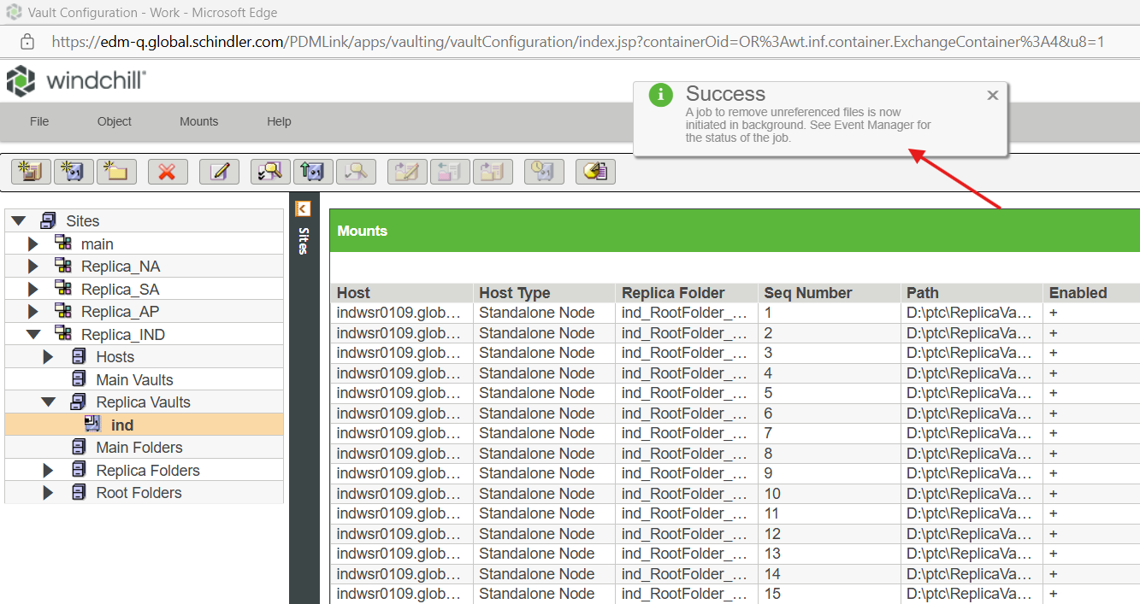

11. Go to Quick Links → click on Event Management to see the status of the job.
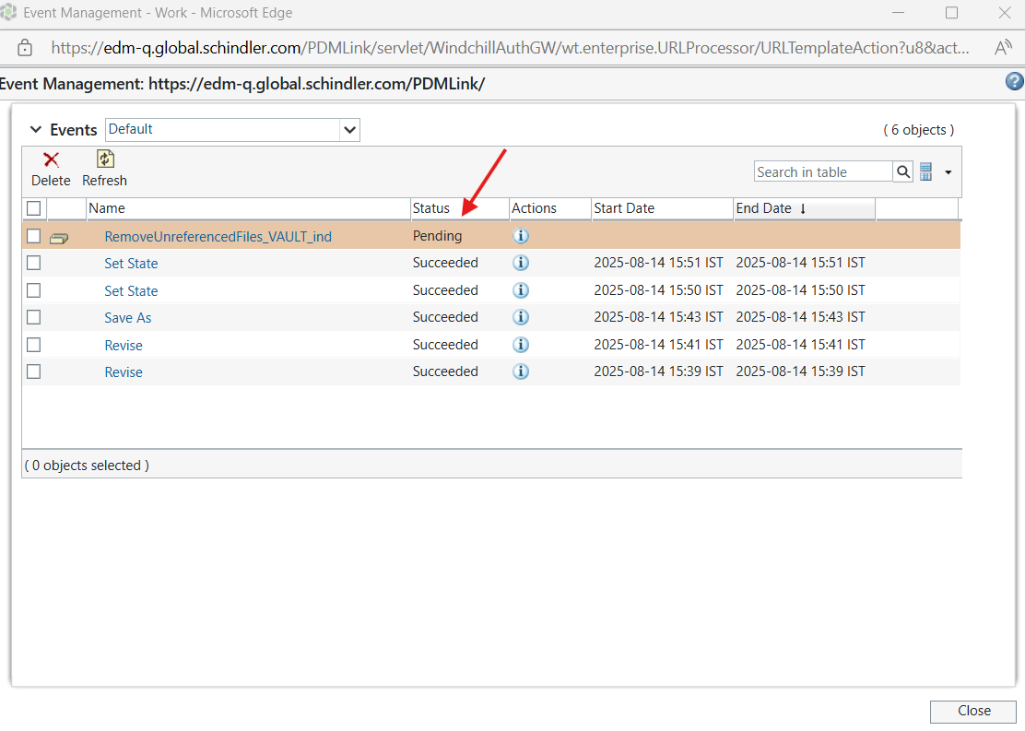

12. Make sure the job executes successfully (it will take some time).
